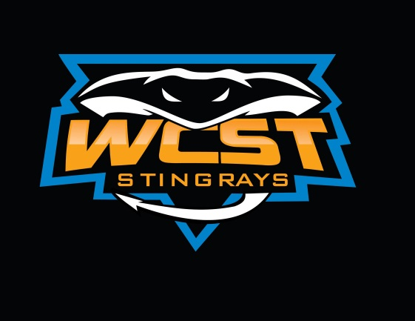
WCST 2022 APPAREL ORDER FORM
Please return your order form and payment to the Booster Folder by May 16. Accepted payments include PayPal or check. Please make checks out to WCST. Payment must be received before order can be processed. All questions can be forwarded to Gina Davey or Kath Kindorf at wcstboosters@gmail.com.
NAME____________________________________________________________________
Available Apparel includes the following:
Item | Size(s) | Total Items | Price | Total Cost
Tagless Cotton Tshirt |  |  | $22 each
Cotton Hoodie |  |  | $42 each
Racer Back Tank Top |  |  | $30 each
Blend Tshirt |  |  | $27 each
TOTAL AMOUNT INCLUDED: ___________________________________________________________________________
Available Sizes
Item | Youth Sizes | Adult Sizes
Tagless Cotton Tshirt | YXS-YXL | S-4XL
Cotton Hoodie | YXS-YXL | S-4XL
Racer Back Tank Top | n/a | XS-4XL
Blend Tshirt | YXS-YXL | XS-4XL
